# Science of BBQ — Burgers

Dr. Amy Powell

Extension Youth Program Specialist, Animal Science

ampowell@iastate.edu

Mike Anderson

Extension Youth Livestock Specialist, 4-H

mikeande@iastate.edu

# Program Overview

The summer series one-day programs are designed for county staff or volunteers to utilize to plan and implement a themed day-long event or activity for up to 24 young people. Facilitation is geared towards county staff, project area leaders, club leaders, or other 4-H volunteers and partners.

# Description

Grades 4–8

This program will introduce participants to charcoal grilling methods. Youth will explore meat science topics of beef, food labeling, and cookery. Participants also will learn food safety and techniques for creating the perfect burger. Each participant will be able to create their own recipe and practice grilling burgers.

# Facilitation Notes

The time for each activity can vary depending on the amount of participants you have and how enthusiastic they are about each activity. It may be helpful to plan ahead for flexibility. None of the activities are reliant on one another, so you might choose to skip or repeat activities based on the group dynamics.

# Agenda

|  |  |  |
| --- | --- | --- |
| Time | Description and Resources | Supplies |
| 9:00–9:45  45 minutes | Welcome and Introduction ActivitiesWelcome Welcome everyone to the event. Explain who you are, your relationship to the 4-H program, and briefly explain the purpose of your time together. The participants today will be exploring grilling ground beef. At the end of the day, there will be a showcase for parents or other visitors. They will be asked to be a part of planning this showcase and being a part of it. Getting to Know You Game Using the list of items related to burgers, write one topic or word on a notecard and make enough notecards so that each participant has a notecard with a unique word. Get Acquainted **Do:** Pass the notecards face down out to each student. Tell them not to look at the card. Have students pair up and ask one of the students to place the notecard on their forehead with the word facing their partner. The partner is to describe the word without saying it, and the student holding the card should try to guess what the card says. Then switch and have the partner hold up their card, and the other student describes.  **Reflect:** What were some of the words? How do the words relate to each other?  **Apply:** Today we will be learning about meat science and, specifically, burgers. Burger Mind Maps Give each student a mind map and a pen. Give them three minutes to fill in each bubble with one fact they currently know or think they know about burgers. Once they are finished brainstorming individually, have them turn to their partner and compare lists. Then go around the room and ask each team to name something from their list. Write this on a flip chart or board. You will come back to this at the end of the day. | * A stopwatch or other time-keeping device * Dry-erase board and/or easel pad and markers * Notecards with words (Appendix A) * Burger mind maps (Appendix B) * Writing instruments |
|  | Learning ActivitiesFrom Pasture to Plate Preparing: Print ear tag cards and punch a hole in each. Print money cards and lifecycle cards. Prepare straw hooks (one per student): Tie/tape a 4–6” piece of dental floss to the end of each straw. Hang one open paper clip (resembling a hook) to the end of the floss.  **Do:** Ask students how beef gets from pasture to plate. Have them share their responses.  Step 1: Use <https://www.beef.org/beef-lifecycle/index.html> to go over the key steps in the beef production cycle.   * Cow/Calf: Cows are bred, and calves are born and raised every year on cow–calf farms and ranches. They spend time grazing on grass pastures within sight of their mothers. * Livestock Auction Markets: Many calves leave the farm or ranch where they were born and are sold at livestock auction markets to stockers and backgrounders between 6–12 months of age. * Stockers and Backgrounders: Between 6–12 months of age, cattle spend time at stocker and backgrounder farms and ranches where they graze on a variety of pastures. Here they gain weight and convert forage and grass into lean protein. * Feed Yard: Cattle spend 4-6 months at a feed yard being fed a scientifically balanced diet and receiving daily care. Some spend the rest of their lives on a pasture being grass finished. * Packing Plant: Cattle are sent to a packer/processing facility to be slaughtered, processed, and then distributed to supermarket retailers and restaurants. * Supermarkets and Restaurants   Step 2: Inform the students that they are going to participate in a team contest that illustrates the beef lifecycle. Break students into teams of six. Give each team a stack of beef lifecycle cards. Each person on the team should take one card. Give students time to review their card. Give each team five money cards. Each team member, except the Cow-calf operator, should hold one money card.  Give each team member a straw paper clip hook. Station team members across the room by team in order of the beef lifecycle stages. Place an ear tag card on a table next to each cow–calf operator. Clarify the challenge: each team will race to carefully move their beef animal (represented by the ear tag) from the cow–calf operation through the beef lifecycle. Students will move the ear tag by placing the straw in his or her mouth and hooking the ear tag through the hole. At each point in the process, the student will hand off the ear tag to the next student, using only the straw hooks. The person receiving the animal will hand one money card to the person delivering the animal.  **Reflect**: What did you observe? What was challenging? How did money play a role?  **Apply**: How do you think this is like the actual beef lifecycle?  *Activity taken from: True Beef: Pasture to Plate https://www.agfoundation.org/files/AFBFA-True-Beef-Lesson-Plan-flow-res.pdf* Where’s the Beef? **Do:** Knowing where on the beef carcass meat comes from can help you decide how to cook meat. Ground meat can actually come from any part of the carcass. Ask for a volunteer to be your beef animal. Have the kids identify the major “wholesale” cuts of the volunteer (legs, rear, ribs, shoulders, arms, etc.) Explain that just like people, cows also have parts, and they are similar to ours but have different names.  Hand out the worksheet and colored pencils to each student. Ask the kids to color the parts of the beef animal, using the guide listed on the handout. Once everyone has colored their pictures,  ask for volunteers to shout out what they think #1 is and go through each of the answers.  Watch the video <https://www.youtube.com/watch?v=dLcY4BEs5CY>  **Reflect:** Where does ground beef come from? Where would ground beef from a whole muscle cut come from? What are trimmings?  **Apply:**  Why is it important to know where ground beef comes from? Labeling Terminology **Do:** Food labels today can be very confusing. Watch the video <https://www.agdaily.com/news/funny-die-video-deceptive-food-labels/>  Ask the group what they thought of the video.  Divide the group into smaller groups of four students. Give each group a set of words and definitions. Ask the students to match the word with its definition. Go over the definitions with the group.  **Reflect:** Were there any labels that you had never heard of before? Which ones?  Why do you think consumers would get confused when purchasing food?  How do you think the different labels affect price?  **Apply:** How does knowing what all these labels mean apply to you or your family purchasing ground beef? What’s on a Label **Do:** When you look at a food label, what do you see? Write responses on the board.  Food labels are required on all products, and they tell us a lot of information.   * Product Name * Inspection Information * Handling Statement * Net Weight * Ingredients * Address * Nutrition Facts * Safe Handling Instructions   Ground beef labels should also tell the consumer how much fat is in the product. If the label says 80/20, then 80% of the ground product is meat, and 20% is fat. Ground beef labels also tell us where the product comes from on the carcass. For example, if it says ground chuck, where is that? If it just says ground beef, then it more than likely comes from the trimmings.  If a product is labeled as “hamburger,” this means it can have beef fat added to it. If a product is labeled as “ground beef,” then it does not have any added fat. Both products may contain up to 30% fat.  Using the same groups as before, give each group a food label. Have them identify some of the labeling information, and then they should create a sales pitch for the product, using all of the information they have learned about labels. Give the teams five minutes to create their sales pitch, and then let each group try to sell their beef to everyone else.  **Reflect:** How do you think food labels affect the price of ground beef? Is there a difference in price between organic and conventional ground beef? What about ground chuck versus ground beef or ground sirloin?  **Apply:** What will you look for next time you purchase ground beef? Food Safety Preparing: “Grind” playdough so that it looks like ground beef and sprinkle with Glo Germ. Create a steak out of play dough and carefully sprinkle the outside of the meat with Glo Germ. Read the Ground Beef and Food Safety fact sheet from USDA for background information.  Do: Ask the students, “What makes our food safe to eat?”  Safe steps in food handling, cooking, and storage are essential in preventing foodborne illness. You can't see, smell, or taste harmful bacteria that may cause illness. In every step of food preparation, follow the four guidelines to keep food safe:   * **Clean—**Wash hands and surfaces often. * **Separate—**Don't cross contaminate. * **Cook—**Cook to proper temperatures, checking with a food thermometer. * **Chill—**Refrigerate promptly.   Why do we have to cook ground beef or any meat product to 160 degrees, but steak can be safely cooked to 145 degrees?  Take out the “ground beef” play dough and ask a student to form it into a patty. Make sure they mix it well so that the Glo Germ is mixed through. Have the student transfer the “meat” to a pan to pretend cook the meat. Ask another participant to take the pre-formed steak and place it in the skillet. See if you can get the participants to touch other things to illustrate how the bacteria spreads if you don’t wash your hands. Using the blacklight, retrace the steps of the students—looking at the counter, cutting boards, hands, and everywhere the student or meat touched a surface. This illustrates how bacteria are spread and why you should not place cooked food on the same platter as the raw meat. Counters, cutting boards, and other items should all be cleaned. Hands should be washed. Take the burger and the steak off the grill and cut into the products. Then use the blacklight to illustrate how the bacteria is spread throughout the entire burger, but it is only on the outside of the steak.  Now, ask the question again, “Why is it important to cook ground product to a higher temperature?” Hopefully the response will be that ground product is exposed to more bacteria because it is not a solid-muscle fiber. Therefore, it is important to cook it all the way through. The steak has only been exposed on the outside since it is a whole muscle.  When meat is ground, more of the meat is exposed to the harmful bacteria. Bacteria multiply rapidly in the “Danger Zone” — the temperatures between 40 and 140° F (4.4 and 60° C). Refrigerate or freeze ground beef as soon as possible after purchase. This preserves its freshness and slows the growth of bacteria. It can be refrigerated or frozen in its original packaging if the meat will be used soon. To keep bacterial levels low, store ground beef at 40° F (4.4° C) or below and use within two days or freeze. Never leave ground beef or any perishable food out at room temperature for more than two hours — one hour at 90° F (32.2 ° C) and above.  How do I know if my meat is cooked? Use a meat thermometer! Using the ground beef play dough patty, illustrate how to take the internal temperature.  Play the food safety game  Finally, introduce students to specific food handling guidelines for ground beef. Place students in groups of three to five. Give each group a set of Food Safety Cards. Each set contains common food safety questions and answers from the United States Department of Agriculture, Food Safety and Inspection Service (2016). Students will race to correctly match the question with the correct response.  Correct answers are as follows: ◦ Q: How do I know if ground beef is fully cooked? ▪ A: To minimize risk of bacteria, ground beef should always be cooked to 160 degrees Fahrenheit.  ◦ Q: How long can I store fresh ground beef? ▪ A: Use or freeze fresh ground beef within two days.  ◦ Q: Why is E. coli a special concern with ground beef? ▪ A: This is a bacterium that can be found in the intestines of animals. Illnesses have been connected to consuming undercooked ground beef. Remember, cook your ground beef to 160 degrees Fahrenheit!  ◦ Q: What happens in a USDA-inspected beef processing plant? ▪ A: Trimmed beef for grinding is inspected for bacteria. Sanitation Standard Operating Procedures are used to make sure equipment is clean and handled properly.  ◦ Q: Can bacteria spread from one surface to another? ▪ A: Yes. It is very important to avoid cross contamination. Keep raw foods and juices separate from cooked or raw foods that won’t be cooked.  ◦ Q: How should I handle ground beef at the store? ▪ A: Try to pick up ground beef last at the store and place in a plastic bag. Take it directly home or place it in a cooler.  ◦ Q: What is the best way to thaw frozen ground beef? ▪ A: Defrosting ground beef in the refrigerator is the best method. Need a faster method? Use cold water or the microwave. Never leave ground beef at room temperature for more than two hours. *Food safety game taken from https://www.agfoundation.org/files/AFBFA-True-Beef-Lesson-Plan-flow-res.pdf* **Reflect:** What temperature should we cook ground meat to in order to insure that it is safe? 160 degrees  Why do we need to cook ground beef to 160 degrees and steaks to 145 degrees?  What are some other ways that we can ensure that our food is safe?  **Apply:** What will you do at home to make sure that you are properly preparing and storing your meat? Grilling Experiment Compare various percentages of lean ground beef or compare different types of ground product. Have the participants record their observations and taste samples of each to compare tenderness, juiciness, flavor, and cost per pound of product.  **Do**: Divide the group into three smaller groups. Assign each group a particular type of meat; you can use Option 1 or Option 2 as ideas:  Discuss proper food safety and handling of raw meat products. Explain what temperature each type of product needs to be cooked at.  Option 1: Label three paper plates with the following % lean ground beef — Group 1 (less than 80% lean), Group 2 (80-85% lean), Group 3 (93% or above lean). Weigh one pound of each product pre-cooked. Grill each patty to appropriate temperature and proper grilling techniques.  Option 2: Label three paper plates with the following different types of ground product — Group 1 (ground beef), Group 2 (ground turkey), Group 3 (veggie burger)  After each group has completed grilling their particular type of product, cut up samples and place on paper plates (optional: you may want to NOT label paper plates to record blind observations). Have each participant record their findings on the form (Appendix J).  **Reflect**: Which sample had the most flavor? Which sample had the least flavor? Which sample was the most/least juicy? Which sample was the highest/lowest cost per pound? Which sample had the most “shrink” from its pre-cooked raw weight to its cooked weight?  **Apply**: How will you use your observations the next time you purchase a ground product? How does cost and flavor influence your buying decision? How could you add more taste/flavor to a leaner cut? Starting the fire **Do**: Show the group how to start a fire using the chimney. The goal with the chimney is to be able to use little or no lighter fluid. This is a much safer way to grill meat because you are not using an accelerant.  https://weber-recipe-database-production.imgix.net/technique_course5b/technique_course5b_1.jpg?w=600&h=600&fit=crop&crop=faces  Step 1: Fill the space under the wire rack with two sheets of wadded up newspaper, and then fill the space above the racks to the top with briquettes. https://weber-recipe-database-production.imgix.net/technique_course5b/technique_course5b.jpg?w=600&h=600&fit=crop&crop=faces Step 2: Light the newspaper, and this will ignite the briquettes Pouring Charcoal Out of the Chimney Starter Step 3: When the coals turn white (about 30 minutes), it is time to dump them out into the grill. Be sure to wear oven mitts or gloves to protect your hands.  Have each pair of kids light their grills. While the coals are getting ready, have each student prepare their burgers. Preparing BurgersRemember food safety! You can have the students look up burger recipes online at <https://www.beefitswhatsfordinner.com/recipes/collection/10039/the-tastiest-burgers>, or they can just create their own recipe. Here are some tips to share with the group:  Remember the label-reading activity we started with today? When selecting the beef to grill use a FAT-TO-BEEF RATIO that will give you 20/80 fat-to-beef ratio. This combination is critical to producing a happy burger. Anything less, and the burger will tend to taste a bit dry; anything more, and it will taste too greasy.  SEASONING THE GROUND BEEF A lot of us like to spice things up a bit by adding some seasoning to the beef before cooking. Some examples of the seasonings: • Freshly Ground Black Pepper • Freshly Ground White Pepper • Chili Powder • Chipotle Powder • Cumin • Mustard Powder • Cinnamon You can try various combinations, depending on the tastes that you are going for; however, don’t over season the beef. A burger with just a hint of spice is good — a burger that’s overpowered with spices is not.  SALT: Mixing salt in with the ground beef is one of the biggest mistakes you can make. The reason you don’t add salt is that salt draws water out of meat and begins to dissolve proteins. This makes the proteins cling together and become springy. Add salt to the burger just before cooking, bring the salt and pepper to the grill with you, and add those spices once on the grill.  SHOULD I LET MY BURGERS REST BEFORE COOKING? No, No, No. There are occasions when we will allow a roast to rest on the countertop before placing into a slow cooker or into the oven but not ground beef. When you put your burgers out to rest, you are just ringing the dinner bell for bacteria. Keep them nice and cool in the fridge, and when you’re ready to grill or pan fry, take them out and cook them. And if you want one, here’s another reason to keep them cold: When the beef hits the hot pan or grill, the coolness will insulate the interior of beef, and slow the cooking process. That way, you can get a nice crisp outside while still having a juicy interior.  MAKING THE PATTIES The first rule in making the burgers is to handle the beef as little as you can. The more you handle the beef, the tougher the finished product will be.  WEIGHT If you are making a standard burger using prepackaged hamburger buns, then around six ounces is a pretty good place to start.   FORMING Since there will be some shrinkage during the cooking process, form the beef into a patty slightly larger than the bun size and use your thumb to make an indentation in the middle of the patty. As the burger cooks and begins to shrink, the indentation will begin filling in, and prevent the burger from “doming.”  KEEP THEM COOL After forming the patties, return them to the fridge until ready to cook.  Have each student pat out their burgers and add whatever spices they would like. Prepping the Grill Your grill should be clean, and it should be at the right temperature. If the grill is too hot, you will burn the outside of the burger before the inside is cooked; if it’s too cold, they won’t release from the grill, and they will most likely turn out dry. Before heating up the grill, hit the grate with a wire brush to knock off any leftover burned bits from the last BBQ session. One of the best ways to grill is to use a two-zone system: one side of the grill is screaming hot, and the other half is lower in temperature. If you are using coals, one side will have more coals than the other; if you are using gas, turn the burners down on one side. The hot side of the grill should be around 450° F (230° C), and the cooler side should be around 300° F (150°C). To test this out, if you hold your hand over the hot side, you should only be able to keep it there for around one second. The cooler side does not have to be so exact; it should be hot, but not screaming hot. Once the grill is hot, wad up a paper towel, dip it in some veggie oil, and run it over the grate. You might get a flair up from the dripping oil, but that’s okay; it will go away. You now have a stick-free grate.  The Two-Zone Fire  **Do:** Take the students outside and have them pour their coals out and try to form the two-zone fire as pictured above. They will also want to make sure that their grill grates are clean. Once they have the fire set up, put the grate on, and then go get the beef. Cooking the Burgers You want the indented side of the burger to be on top, so flip to the other side, season with salt and pepper (if using), and then place the seasoned side on the hot grill. Lay the burgers on the hot side of the grill and allow them to cook undisturbed for two minutes. Then season the top side with salt and pepper, flip the burgers, and cook an additional two minutes. Move them over to the cooler side and continue cooking until it reaches an internal temperature of 160 degrees.  LEAVE THE BURGERS ALONE Never ever use your spatula to press down on the burgers — that’s another rookie mistake. All you are doing is pushing the juices out of the burger and dropping them onto the hot coals. Leave them alone.  WHAT ABOUT THE CHEESE It’s all in the timing. Most people put the cheese on too soon, and it winds up dripping off the burgers and onto the hot coals — what a waste of good cheese. Add the cheese in the last minute of cooking.  SHOULD I COVER THE GRILL WHILE THE BURGERS ARE COOKING? In most cases, the answer to that question is no. When you cover your grill, you are essentially turning it into an oven. Are you baking these burgers, or are you grilling them? Burgers are best grilled with the majority of the heat coming from the bottom. When you cover the grill, you are surrounding them with heat. The results of a covered grill will be dryer burgers.  SERVING SUGGESTION Serve as soon as they are cooked. The longer they sit around, the dryer they will become.  **Do**: Grill the burgers! Eat the burgers!  **Reflect**: What did you like about your burger?  What would you change about your burger? Pull out the list you made at the beginning of the day and let the students make edits to the list, based on what they learned throughout the day.  **Apply**: Do a go-round and ask each student to tell one thing that they will do as a result of something they learned today. Give them a few moments to think, and then ask for a volunteer to go first. Then go around the room and get responses from everyone. | Pasture to Plate   * Straws * Dental floss * Paper clips * Ear tag cards (Appendix C) * Money cards (Appendix D) * Lifecycle cards (Appendix E) * The Beef Lifecycle poster website   Where’s the Beef?   * Where’s the Beef? wholesale handout (Appendix F) * 7 different colored pencils or markers for each student.   Labeling Terminology   * Projector or TV to watch video * Food label definitions and words (Appendix G)   What’s on a Label   * Food label worksheet (Appendix H)   Food Safety   * Play dough * Glo Germ powder * Blacklight * Cutting board * Skillet * Food safety Cards (Appendix I) * Meat thermometer   Grilling Experiment   * Meat thermometer * Small digital scale (optional) * Wax paper * Paper plates   Starting the Fire   * Grills (12) * Chimneys (12) * Charcoal * Newspaper * Lighters   Preparing Burgers   * Ground beef (6oz per serving) * Seasonings * Recipes (optional) * Plates or cutting boards to pat out burgers   Prepping the Grill   * Tongs for moving charcoal * Oven mitts * Grill brush or something to clean grill grate * Grill spray or paper towels with vegetable oil   Cooking (1 per grill)   * Spatula for turning meat * Clean plate to place cooked burger on * Meat thermometers   Eating   * Buns * Condiments |

References

## Appendix A – Notecards

Write one word per notecard

1. Beef
2. Hamburger
3. Grilling
4. Meat thermometer
5. Pork
6. Chicken
7. Lamb
8. Turkey
9. Charcoal
10. Food safety
11. Food label
12. Chef
13. Meat science
14. BBQ
15. Ingredients
16. Red meat
17. Tongs
18. Buns
19. Gas grill
20. Spices
21. Cheese
22. Ketchup
23. Pickles
24. Lettuce

## Appendix B – Mind Map

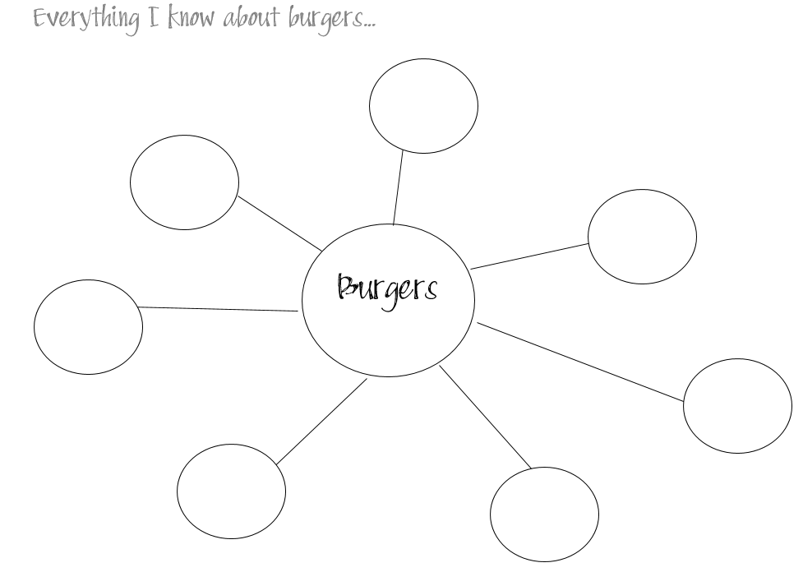

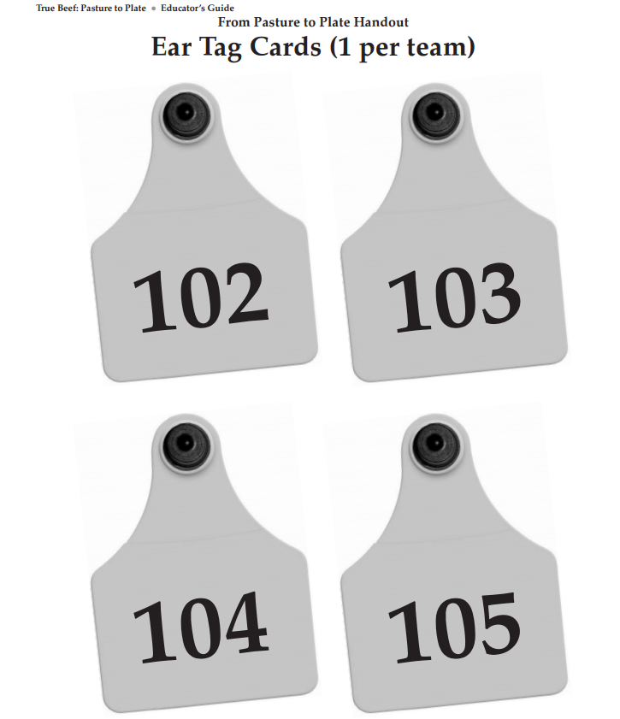

## Appendix D- Money Cards

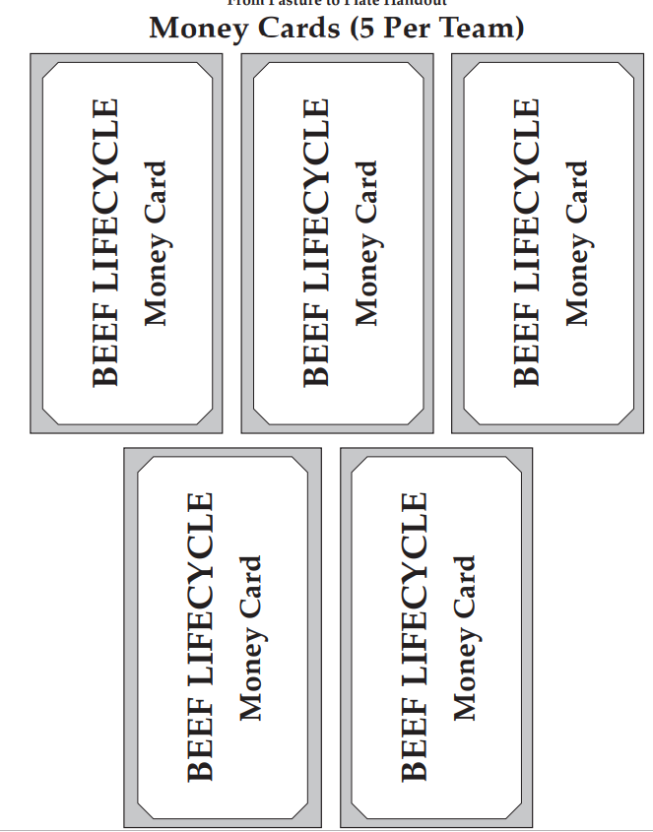

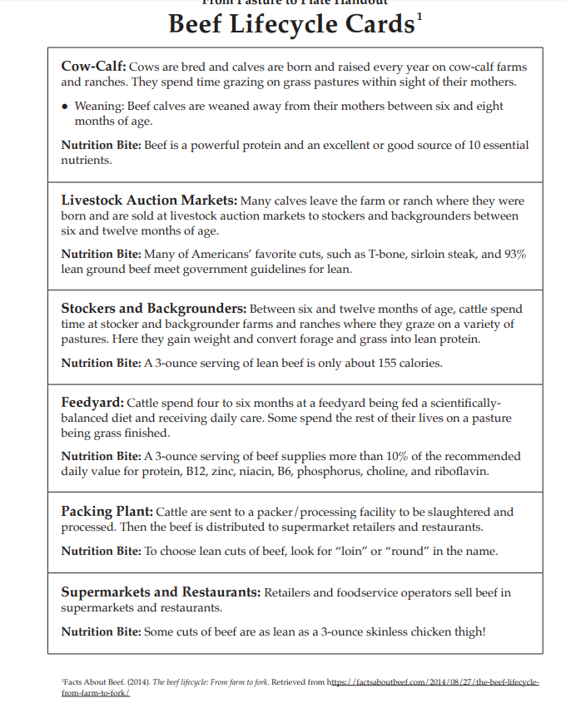

## Appendix F

**Where’s the Beef?**



Chuck (Blue)

Rib (Red)

Loin (Green)

Round (Purple)

Brisket (Orange)

Plate (Yellow)

Flank (Brown)

|  |  |
| --- | --- |
| 100% Grass Fed or Grass Fed Only  Related image | Grass Fed |
| Organic | Free Range/ Free Roaming |
| No antibiotics added/ Raised without antibiotics  Image result for raised without antibiotics beef | Natural or All Natural |
| Naturally Raised | No Animal By- Products |
| Certified Humane Raised and Handled | Meat is produced from animals that were fed only grass, hay, and other non-grain vegetation for their entire lives and, therefore, not grains and no animal by-products. |
| Meat is produced from animals that ate grass at some point during their lives. | Meat comes from a farm that prohibits using animal by-products or antibiotics or related drugs in the feed for farm animals. All food with this label must be verified by an independent organization |
| These labels only apply to poultry, but it means that the animal was allowed access to the outdoors. | This label indicates that the animals have not been fed antibiotics at any point during their lives. There is not a third-party certification for this type of label. |
| This is a meat product that contains no additives or preservatives or added color and is only minimally processed, although it does allow flavor injections. It is not regulated, and there are no national standards. | This means livestock used for the production of meat and meat products have been raised entirely without growth promotants, antibiotics, and have never been fed mammalian or avian by-products. |

|  |  |
| --- | --- |
| Meat should come from animals that were fed feed without animal by-products. These claims are not necessarily verified by an outside source unless the USDA-verified shield appears on the package. | This label means that a producer has met the standards of Humane Farm Animal Care. |
| GMO Free | This label does not apply to any meat product because there is no such thing. |
| Animal Welfare Approved | This is the only label that guarantees animals are raised outdoors on pasture or range for their entire lives on an independent farm using truly sustainable, high-welfare farming practices. It is the only label in the U.S. to require audited high-welfare production, transport and slaughter practices, and has the single highest impact on consumer purchasing of any food label, according to The Hartman Group. |

## Appendix H – Food Labels

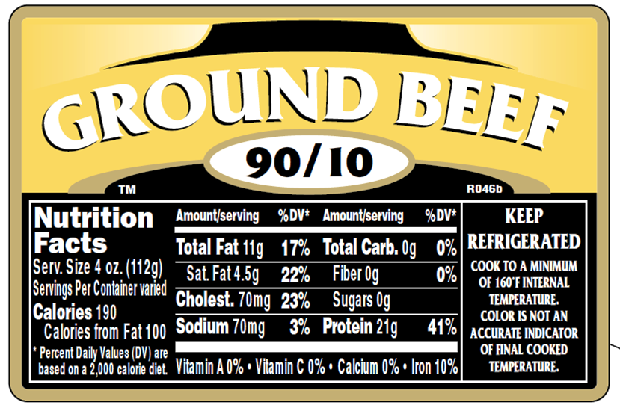

What’s on a label?

* Product Name
* Inspection Information
* Handling Statement
* Net Weight
* Ingredients
* Address
* Nutrition Facts
* Safe Handling Instructions

What is unique about this label?

Is the beef from a whole muscle or trimmings?

How much fat is in the product?

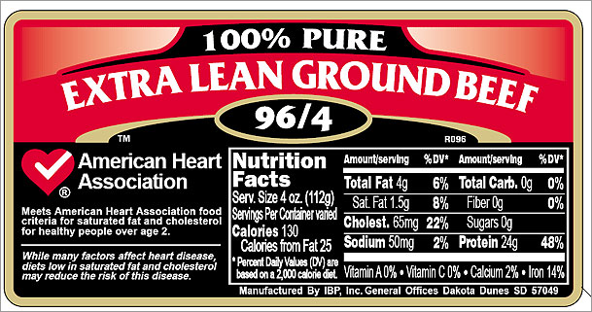

What’s on a label?

* Product Name
* Inspection Information
* Handling Statement
* Net Weight
* Ingredients
* Address
* Nutrition Facts
* Safe-Handling Instructions

What is unique about this label?

Is the beef from a whole muscle or trimmings?

How much fat is in the product?

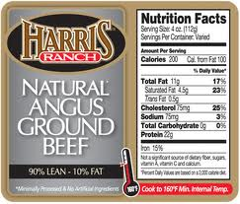

What’s on a label?

* Product Name
* Inspection Information
* Handling Statement
* Net Weight
* Ingredients
* Address
* Nutrition Facts
* Safe-Handling Instructions

What is unique about this label?

Is the beef from a whole muscle or trimmings?

How much fat is in the product?

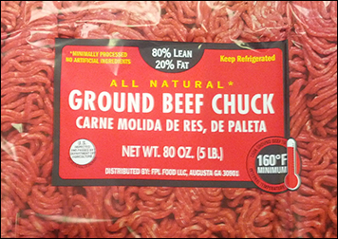

What’s on a label?

* Product Name
* Inspection Information
* Handling Statement
* Net Weight
* Ingredients
* Address
* Nutrition Facts
* Safe-Handling Instructions

What is unique about this label?

Is the beef from a whole muscle or trimmings?

How much fat is in the product?

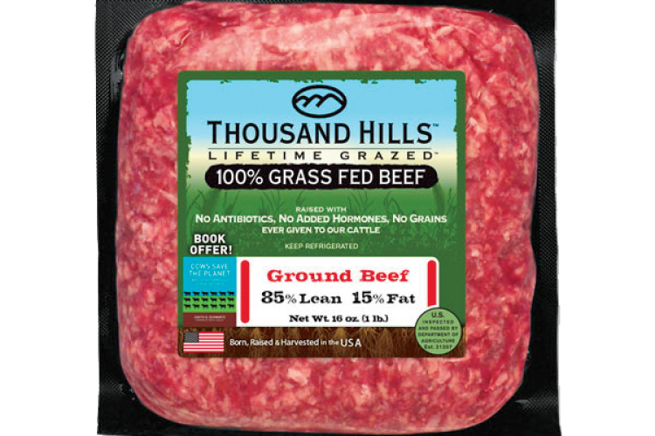

What’s on a label?

* Product Name
* Inspection Information
* Handling Statement
* Net Weight
* Ingredients
* Address
* Nutrition Facts
* Safe-Handling Instructions

What is unique about this label?

Is the beef from a whole muscle or trimmings?

How much fat is in the product?

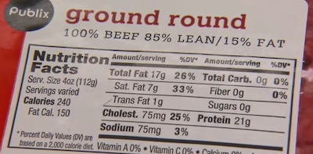

What’s on a label?

* Product Name
* Inspection Information
* Handling Statement
* Net Weight
* Ingredients
* Address
* Nutrition Facts
* Safe-Handling Instructions

What is unique about this label?

Is the beef from a whole muscle or trimmings?

How much fat is in the product?

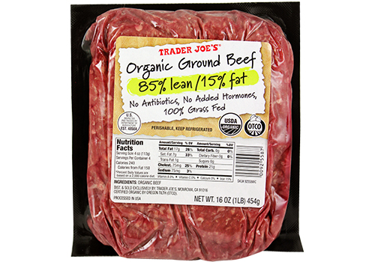

What’s on a label?

* Product Name
* Inspection Information
* Handling Statement
* Net Weight
* Ingredients
* Address
* Nutrition Facts
* Safe-Handling Instructions

What is unique about this label?

Is the beef from a whole muscle or trimmings?

How much fat is in the product?

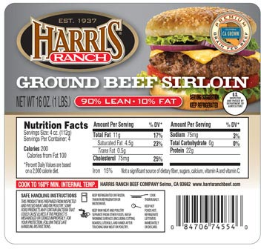

What’s on a label?

* Product Name
* Inspection Information
* Handling Statement
* Net Weight
* Ingredients
* Address
* Nutrition Facts
* Safe-Handling Instructions

What is unique about this label?

Is the beef from a whole muscle or trimmings?

How much fat is in the product?

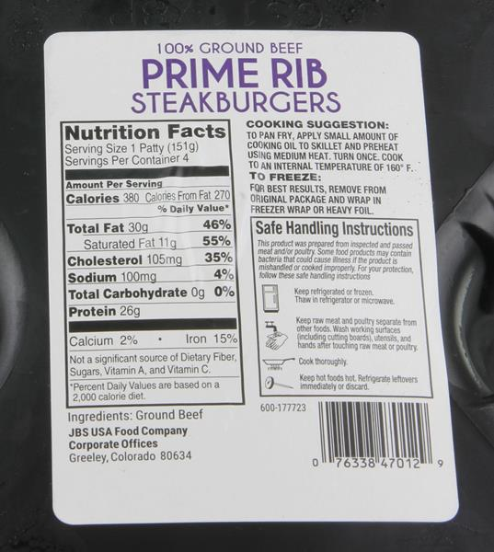

What’s on a label?

* Product Name
* Inspection Information
* Handling Statement
* Net Weight
* Ingredients
* Address
* Nutrition Facts
* Safe-Handling Instructions

What is unique about this label?

Is the beef from a whole muscle or trimmings?

How much fat is in the product?

## Appendix I – Food Safety Cards

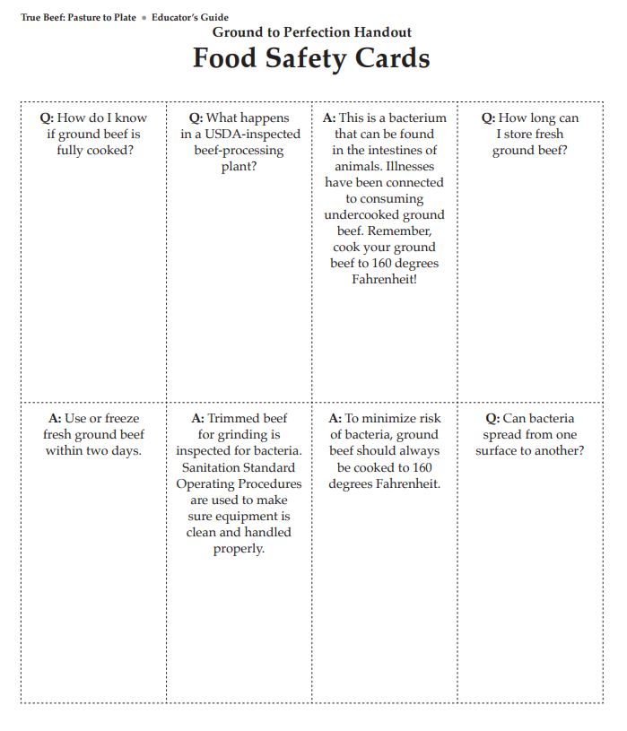

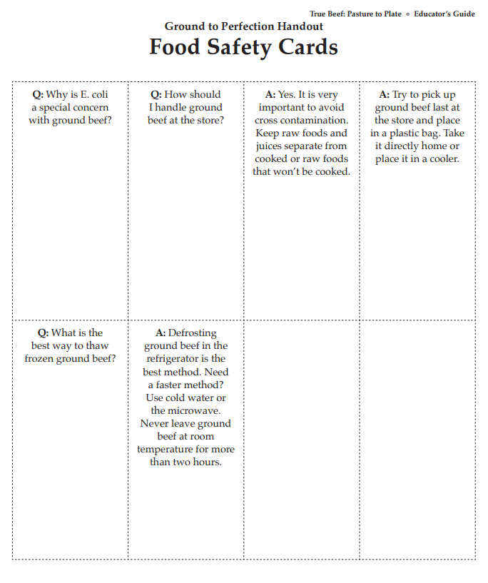

**Tips for Grilling Great Burgers**

FAT-TO-BEEF RATIO look for a combination that will give you 20/80 fat-to-beef ratio. This combination is critical to producing a happy burger. Anything less, and the burger will tend to taste a bit dry; anything more, and it will taste too greasy.

SEASONING THE GROUND BEEF A lot of us like to spice things up a bit by adding some seasoning to the beef before cooking. Some examples of the seasonings: • Freshly Ground Black Pepper • Freshly Ground White Pepper • Chili Powder • Chipotle Powder • Cumin • Mustard Powder • Cinnamon You can try various combinations, depending on the tastes that you going for; however, don’t over season the beef. A burger with just a hint of spice is good — a burger that’s overpowered with spices is not.

SALT: Mixing salt in with the ground beef is one of the biggest mistakes you can make. The reason you don’t add salt is that salt draws water out of meat and begins to dissolve proteins. This makes the proteins cling together and become springy. Add salt to the burger just before cooking bring the salt and pepper to the grill with you and add those spices once on the grill.

SHOULD I LET MY BURGERS REST BEFORE COOKING? No, No, No. There are occasions when we will allow a roast to rest on the countertop before placing into a slow cooker or into the oven but not ground beef. When you put your burgers out to rest, you are just ringing the dinner bell for bacteria. Keep them nice and cool in the fridge and when you’re ready to grill or pan fry, take them out and cook them. And, if you want one, here’s another reason to keep them cold: when the beef hits the hot pan or grill, the coolness will insulate the interior of beef and slow the cooking process. That way you can get a nice crisp outside while still having a juicy interior.

MAKING THE PATTIES The first rule in making the burgers is to handle the beef as little as you can. The more you handle the beef, the tougher the finished product will be.

WEIGHT If you are making a standard burger using prepackaged hamburger buns, then around six ounces is a pretty good place to start.

 FORMING Since there will be some shrinkage during the cooking process, form the beef into a patty slightly larger than the bun size and use your thumb to make an indentation in the middle of the patty. As the burger cooks and begins to shrink, the indentation will begin filling in, and prevent the burger from “doming.”

KEEP THEM COOL After forming the patties, return them to the fridge until ready to cook.

PREPPING THE GRILL Your grill should be clean, and it should be at the right temperature. If the grill is too hot, you will burn the outside of the burger before the inside is cooked; if it’s too cold, they won’t release from the grill, and they will most likely turn out dry. Before heating up the grill, hit the grate with a wire brush to knock off any leftover burned bits from the last BBQ session. When I grill burgers, I use a two-zone system. One side of the grill is screaming hot, and the other half is lower in temperature. If you are using coals, one side will have more coals than the other; if you are using gas, turn the burners down on one side. The hot side of the grill should be around 450° F (230° C), and the cooler side should be around 300° F (150° C). To test this out, if you hold your hand over the hot side, you should only be able to keep it there for around one second. The cooler side does not have to be so exact; it should be hot but not screaming hot. Once the grill is hot, wad up a paper towel, dip it in some veggie oil, and run it over the grate. You might get a flair up from the dripping oil, but that’s okay; it will go away. You now have a stick-free grate.

COOKING THE BURGERS You want the indented side of the burger to be on top — so flip to the other side, season with salt and pepper (if using), and then place the seasoned side on the hot grill. Lay the burgers on the hot side of the grill, and allow them to cook, undisturbed, for two minutes. Then season the top side with salt and pepper, flip the burgers, and cook an additional two minutes. Move them over to the cooler side and continue cooking until it reaches an internal temperature of 160 degrees.

LEAVE THE BURGERS ALONE Never ever use your spatula to press down on the burgers — that’s another rookie mistake. All you are doing is pushing the juices out of the burger and dropping them onto the hot coals. Leave them alone.

WHAT ABOUT THE CHEESE It’s all in the timing. Most people put the cheese on too soon, and it winds up dripping off the burgers and onto the hot coals — what a waste of good cheese. Add the cheese in the last minute of cooking.

SHOULD I COVER THE GRILL WHILE THE BURGERS ARE COOKING? In most case, the answer to that question is no. When you cover your grill, you are essentially turning it into an oven. Are you baking these burgers, or are you grilling them? Burgers are best grilled with the majority of the heat coming from the bottom. When you cover the grill, you are surrounding them with heat. The results of a covered grill will be dryer burgers. I HATE it when that happens.

SERVING SUGGESTION Serve as soon as they are cooked. The longer they sit around, the dryer they will become. This is not a steak or roast that needs to rest. Use the “1,2,3 method”: Off the grill, on the bun, in the mouth — It’s as simple as 1,2,3.

Appendix J

**Ground Product Grilling Experiment Comparison**

|  |  |  |  |  |  |
| --- | --- | --- | --- | --- | --- |
| **Sample** | **%- lean ground beef** | **Weight-raw** | **Weight-cooked** | **Cost/ pound** | **Flavor / Comments** |
|  |  |  |  |  |  |
|  |  |  |  |  |  |
|  |  |  |  |  |  |
|  |  |  |  |  |  |
|  |  |  |  |  |  |